|  |  |
| --- | --- |
| HashiCorp Vault: Data Encryption & Protection  CRYPT  DATA ENCRYPTION VAULT | SAMARTH PATEL  COMPUTER SCIENCE |

SYSTEM REQUIREMENTS

Recommended System Requirements

* Processors: Intel® Core™ i3 processor 4300M at 2.60 GHz.
* Disk space: 2 to 4 GB.
* Operating systems: Windows® 10, macOS, and UBUNTU.
* Python Versions: 3.X.X or Higher

Minimum System Requirements

* Processors: Intel Atom® processor or Intel® Core™ i3 processor
* Disk space: 1 GB
* Operating systems: Windows* 7 or later, macOS, and Linux
* Python* versions: 2.7.X

PREREQUISITES BEFORE INSTALLING MYSQL CONNECTOR PYTHON

You need root or administrator privileges to perform the installation process.

Python must be installed on your machine.

Note: – MySQL Connector Python requires python to be in the system’s PATH. Installation fails if it doesn’t find Python.

On Windows, If Python doesn’t exist in the system’s PATH, please manually add the directory containing python.exe yourself

INTRODUCTION

I have designed a Data Encryption Vault. A Vault provides Encryption as a Service[EaaS] to enable security teams to fortify data during transit and at rest. So even if an intrusion occurs, your data is encrypted and the attacker would never get a hold of the raw data.

The program uses AES[Advanced Encryption Standard] 128-bit encryption.

The program uses Fernet module from the Cryptography package

CODE[CRYPT]

IMPORTING NECESSARY MODULES

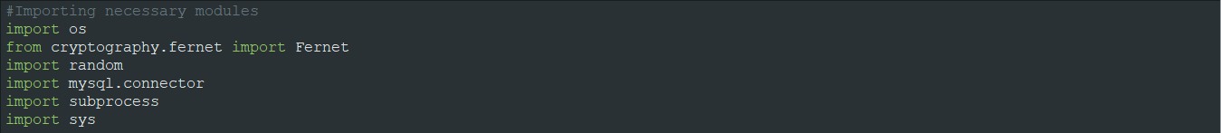

ESTABLISHING CONNECTION BETWEEN SQL AND PYTHON



DEFINING EXECUTION INTERFACE

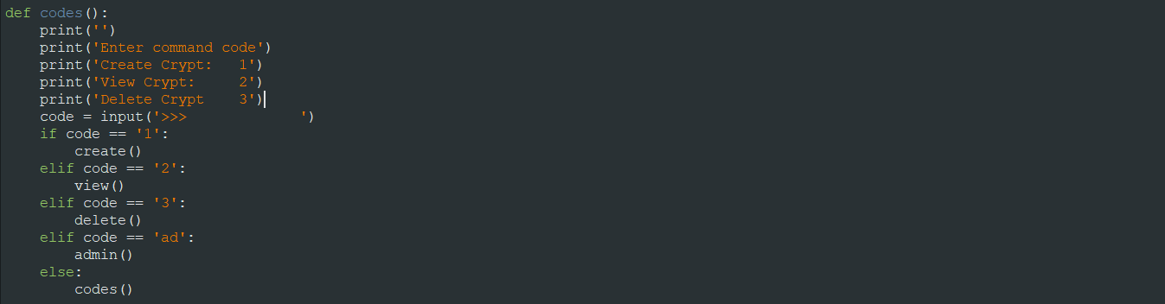

DEFINING FUNCTION FOR CRYPT CREATION

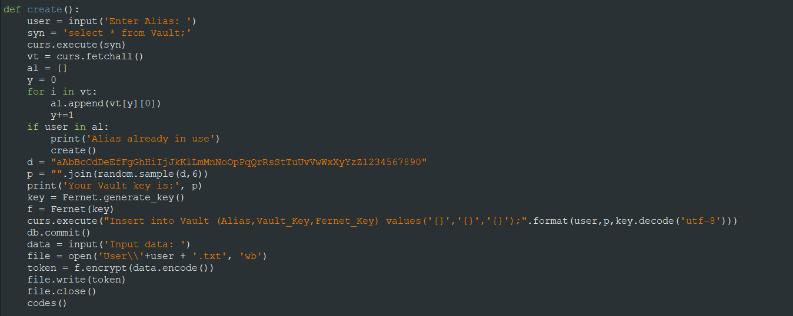

DEFINING FUNCTION FOR CRYPT ACCESS

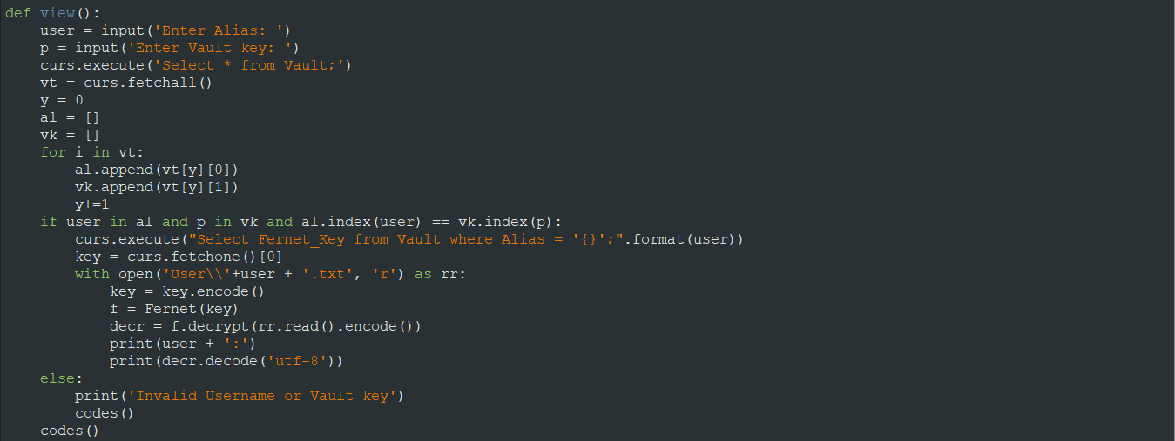

DEFINING ADMIN ACCESS FUNCTION

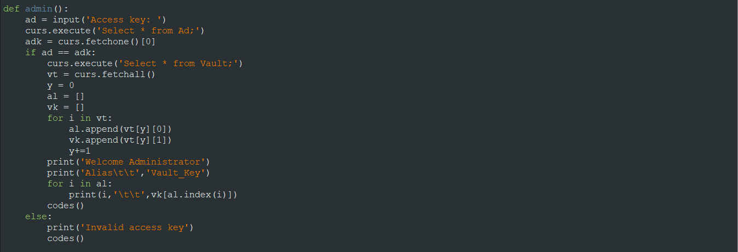

DEFINING FUNCTION FOR CRYPT EXCISING

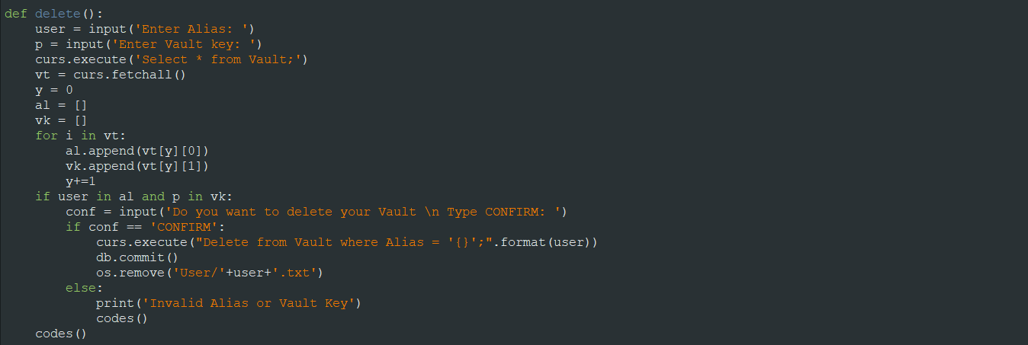

CALLING EXECUTION INTERFACE



OUTPUT[CRYPT]

CREATING CRYPT

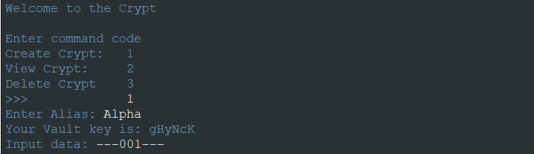

ACCESSING EXISTING CRYPT

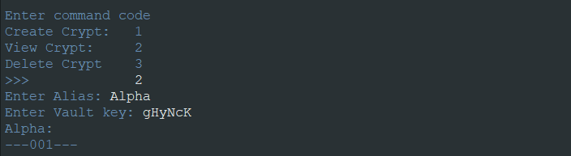

DELETETING CRYPT

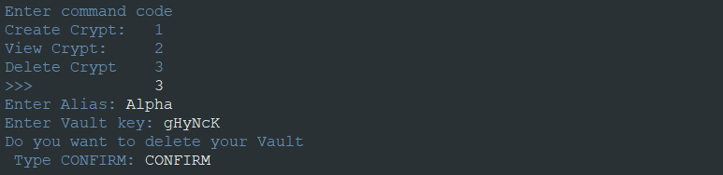

INCORRECT KEY OR ALIAS

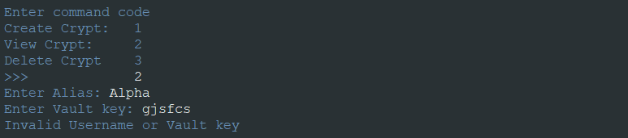

ADMINISTRATOR ACCESS

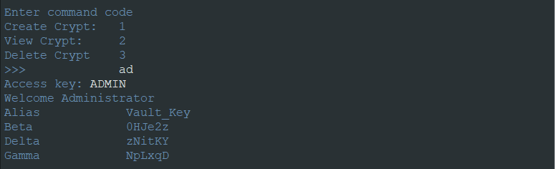

CIPHERTEXT

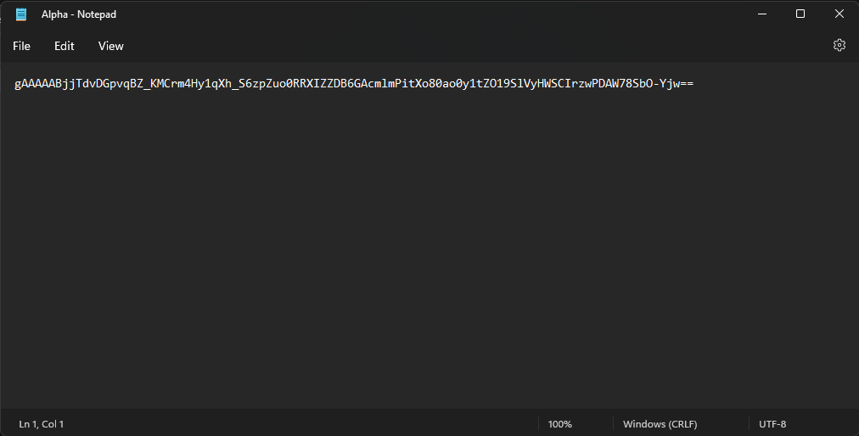

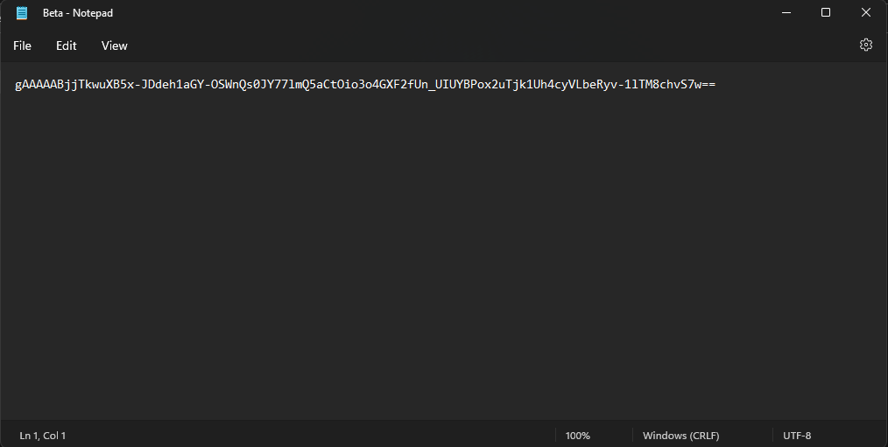

PLAINTEXT





PRE-DELETION

USER DIRECTORY

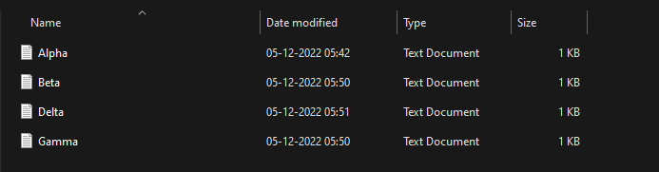

USER CREDENTIALS [IN CRYPT[DATABASE]]

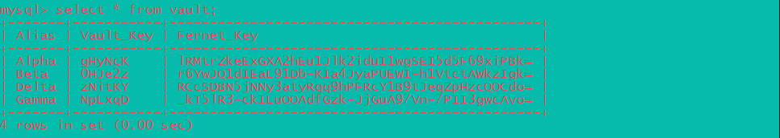

POST-DELETION

USER DIRECTORY

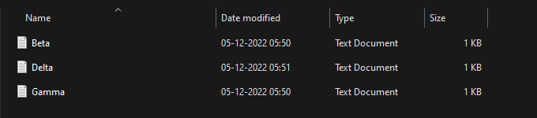

USER CREDENTIALS [IN CRYPT[DATABASE]]

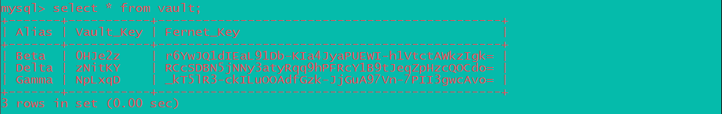

BIBLIOGRAPHY

[www.wikipedia.org](http://www.wikipedia.org)

[www.youtube.com](http://www.youtube.com)

[www.stackexchange.com](http://www.stackexchange.com)

[www.quora.com](http://www.quora.com)

[www.useblackbox.io](http://www.useblackbox.io)

[www.w3schools.com/python](http://www.w3schools.com/python)

[www.geeksforgeeks.org](http://www.geeksforgeeks.org)

[www.python.org](http://www.python.org)